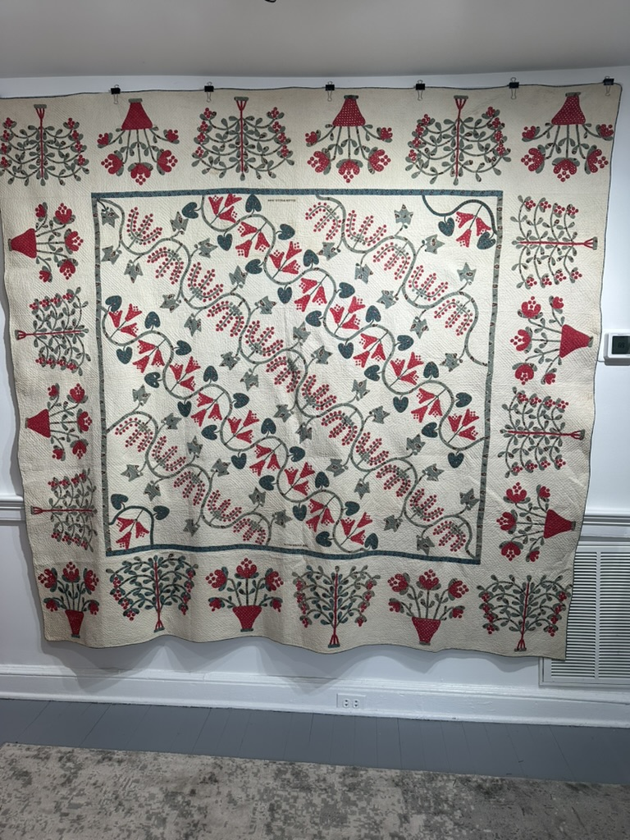
1844 Ellen Wells Quilt

1844 ELLEN WELLS QUILT

Ellen Wells was born April 16, 1827 and died January 25, 1914 from acute bronchitis.
Her father Matthew Wells was born 1791 in Ireland and was Scots-Irish. He was a farmer and arrived in America approximately 1820. Matthew died December of 1873.
Her mother Jane McNall was born in Pennsylvania in 1793 and died in 1871. Jane was also Scots-Irish.
Ellen lived her entire life in Allegheny County, Findlay Township, Pennsylvania. This particular area is where the Pittsburgh Airport is located today. She married Robert McAyeal around 1849 who was also Scots-Irish. Robert was born in 1823 and died 1898.
After the death of her husband, Robert, she lived with her youngest unmarried daughter, Mary McNall McAyeal. In Ellen’s will, she gave all her personal property to Mary, but it did not include the quilt. The quilt was in the possession of Ida McAyeal Yingling, another daughter, and continued to pass down through her family. The final caretaker was Jane Green, Ellen Wells’ great greatgranddaughter. It was through Jane that the quilt came into the possession of the Christ Collection.
Ellen Wells is buried in the Robinson Church Cemetery, Washington County, Pennsylvania,alongside her husband and parents.
The quilt has a vertical design showcasing exquisite quilting.It is inscribed with cross-stitched lettering in two locations, with “Ellen Wells” and “1844.”

