“INDIGO Splendor”
Circa 1850
Pride of Pennsylvania Pattern Series
(Two separate sized patterns included)
“INDIGO SPLENDOR”
Circa 1850
Indigo is a plant-based dye that is primarily found in a tropical plant called Indigofera tinctoria. The plant was grown in Pakistan and India more than 5,000 years ago. It is colorfast and became a profitable agricultural crop. In the 1730’s Eliza Lucas was successful in making enough indigo seed to share with their neighbors of the southern Carolina plantations. The American colonies won their independence at the end of the Revolutionary War but lost the indigo market. It was at that time the profitable crops became rice and cotton.

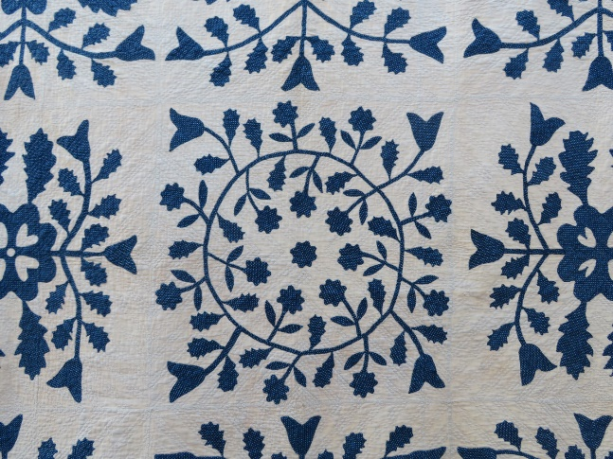
Original Center Block 8 surrounding blocks
(25” finished block) (25” finished blocks)

© The Christ Collection 2023

